Version 1.0

Revision History

|  |  |  |  |
| --- | --- | --- | --- |
| **Date** | **Version** | **Description** | **Author** |
| 28/12/2019 | 1.0 | Final | Nguyen Khac Phuc |
|  |  |  |  |
|  |  |  |  |
|  |  |  |  |

Table of Contents

1. Update report 4

1.1 Brief Description 4

2. Flow of Events 4

2.1 Basic Flow 4

2.2 Actor 5

3. Special Requirements 5

3.1 Requirement step. 5

4. Preconditions 5

5. Postconditions 5

6. Extension Points 5

# Update report

## Brief Description

This use-case defines the step of update a report. Admin can easily update a report by find a report with its id and then update it with just a few steps.

# Flow of Events

## Basic Flow

* Users log in with the admin account. Admin clicks manage salary button, then enter the id of the report. After that, admin clicks search button, the information of the report will appear on the view then clicks the update button. After clicked update button, the frame of update section appears. Admin edit the field which wanted to edit then click submit button. The system will show successfully message if update is success or else it will show failed

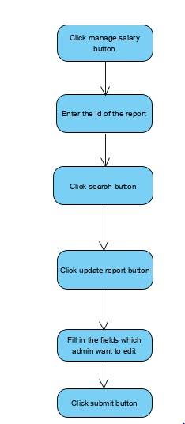

## Actor

-Administrator

# Special Requirements

## Requirement step.

-Id of the report must be filled before click update button or search button.

# Preconditions

* User must log in into the system with the admin account

# Postconditions

* Show message if update report success, the system will show successfully message or else the system will show failed message

# Extension Points